One More Voice
Permission and Imaging Specifications

Below, we set out the model One More Voice permission statement and imaging specifications for collaborating institutions. Our principal goal, however, is to publish relevant primary and secondary materials in digital form, so we are happy to defer to institution-specific permission guidelines and imaging standards as needed.

Sample Permission Statement

[Collaborating Institution] gives the One More Voice (https://onemorevoice.org/) project permission to publish relevant materials under the Creative Commons Attribution 4.0 International (CC BY 4.0) license (https://creativecommons.org/licenses/by/4.0/). Please credit all images as “© [Collaborating institution]”.

Sample Imaging Specifications
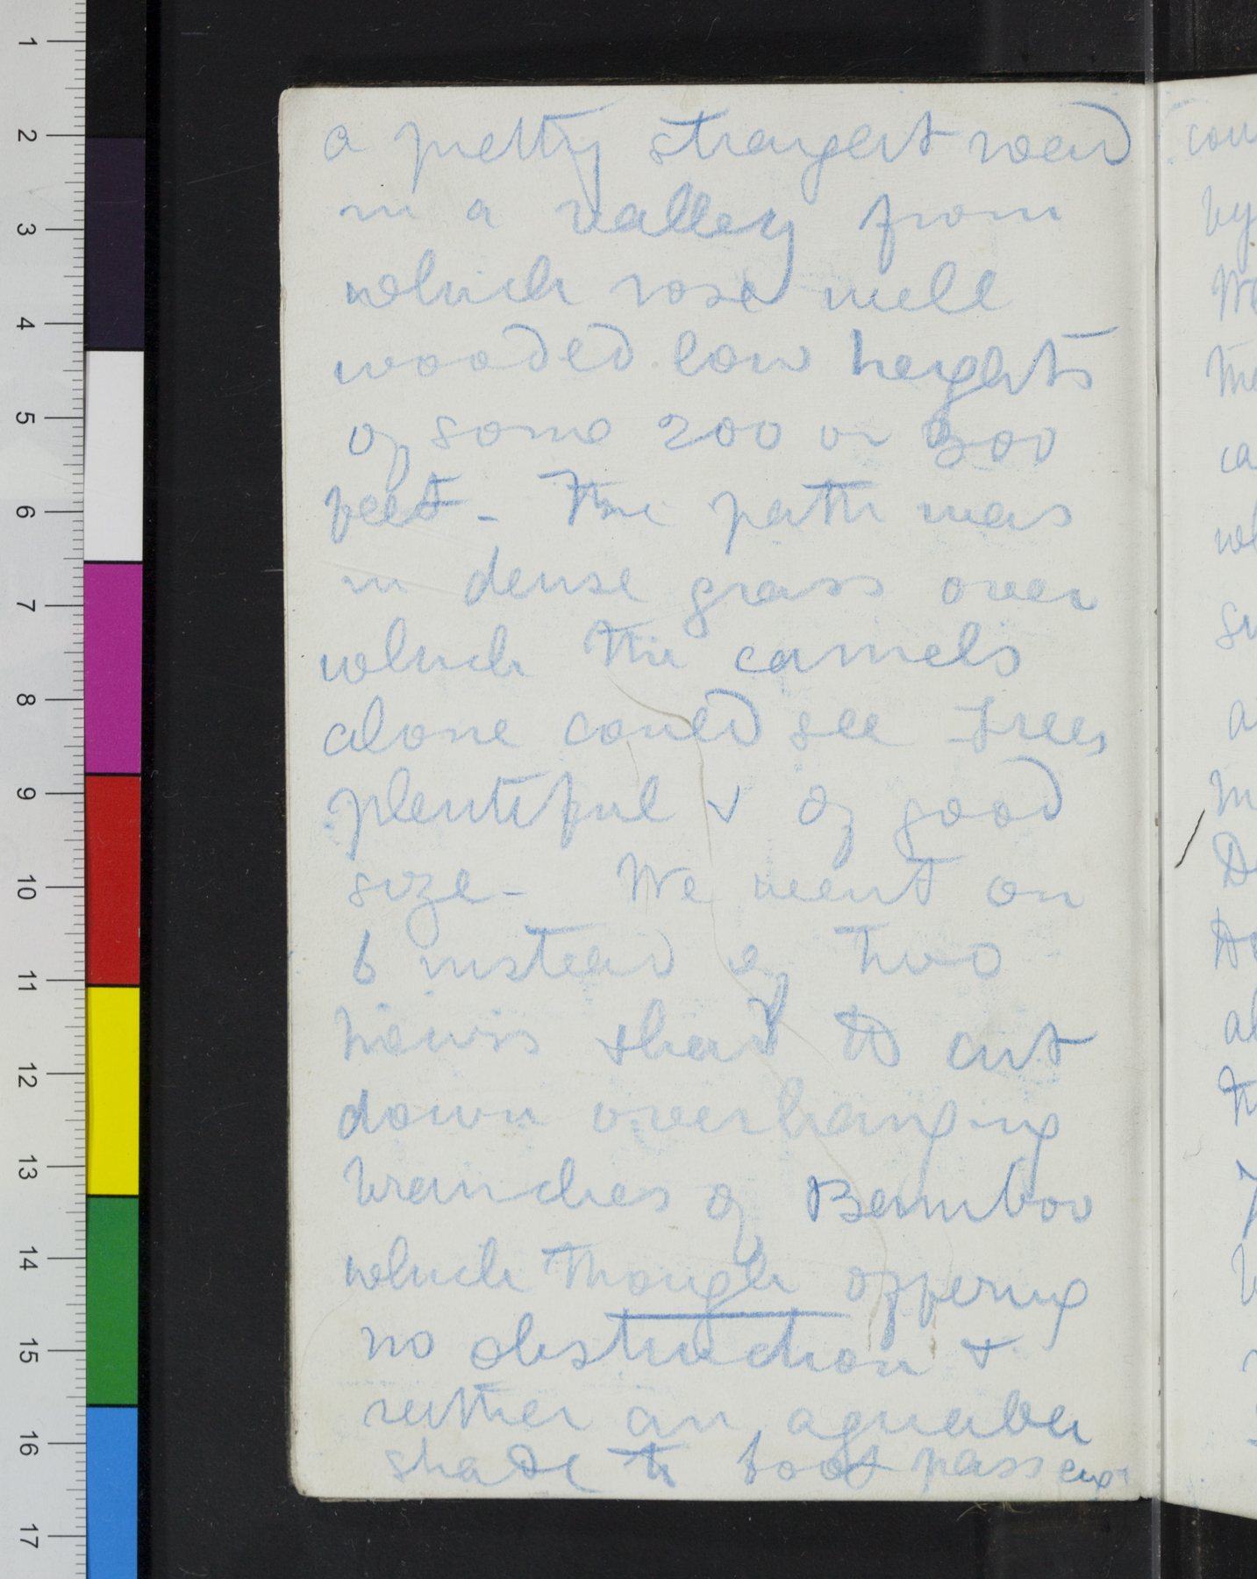  Sample image created to  One More Voice specifications | Format: TIFF images, 8 bit, 600 dpi, 6.0 TIFF specification  JPEG Images: Not needed. We prefer to receive TIFFs and create our own derivatives. As a general rule, we keep TIFF images behind the scenes and do not share them with members of the public without prior permission.  Image Background: Black  Image Layout: See sample image to left and notes below.  1) Please do not crop images. All four edges of a given page should be fully visible.  2) Two-page spreads should be done one page at a time, with a small portion of the adjacent page visible in the image.  3) Please include ruler and color chart, if possible.  Scope: Please image recto and verso of all pages, even if one side of page is blank.

